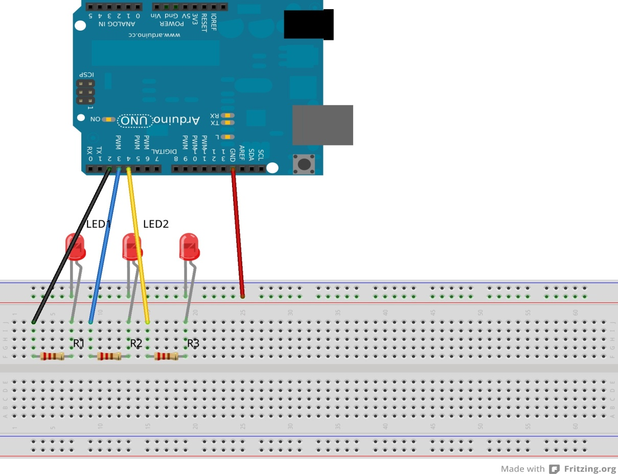

**Theory**

* **Concept Used:**

This expreiment involves the flashing of three LEDs onr by onenusing ARDUINO.

For this exp., the circuit needs to be connected as shown in the diagram above.

* **Learning an observations:**

Following observations were recorded during the experiment.

* The LEDs flash in the pattern set in the sketch of a particular experiment.
* The program uploaded into the ARDUINO starts executing as soon as the power is supplied and goes on executing in a loop till the power is supplied.
* There are certain time delays in between consequent LED flashes which are according to ones defined in the sketch.
* **Problems and Troubleshooting:**
* The problem faced while performing the experiment was the error in uploading which was “the program is not responding” error.
* The error was troubleshooted by re connecting the the USB cable tightly.
* **Precautions:**

The following precautions needs to be taken while performing this experiment .

* The connectins of the USB in both PC and ARDUINO both should be in sung.
* The USB of PC and ARDUINO shpuld be in working condition.
* The sketch should be logically and syntactically correct and germane to the experiment that needs to be performed.
* Look for the errors during compilation and upload the executable to the ARDUINO.
* **Learning outcomes:**
* Ability to distinguish between the various parts of the ARDUINO and learn the basic code of how circuit works.
* Ability to write the basic code required for reading or writing digital values from/to a pin.